**OS LAB 03**

**Shell Scripting in Linux**

**Taskno_01:**

**Before Changing name :**



**After changing name:**



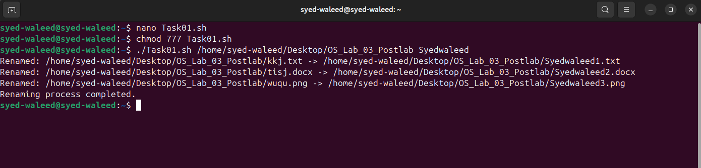

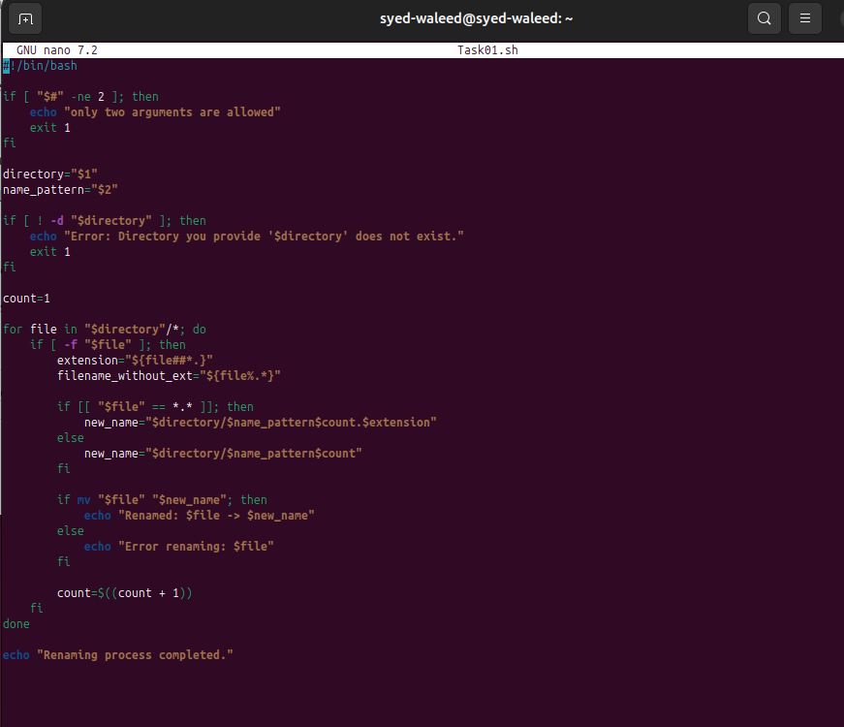

**Code:**

#!/bin/bash

if [ "$#" -ne 2 ]; then

echo "only two arguments are allowed"

exit 1

fi

directory="$1"

name_pattern="$2"

if [ ! -d "$directory" ]; then

echo "Error: Directory you provide '$directory' does not exist."

exit 1

fi

count=1

for file in "$directory"/*; do

if [ -f "$file" ]; then

extension="${file##*.}"

filename_without_ext="${file%.*}"

if [[ "$file" == *.* ]]; then

new_name="$directory/$name_pattern$count.$extension"

else

new_name="$directory/$name_pattern$count"

fi

if mv "$file" "$new_name"; then

echo "Renamed: $file -> $new_name"

else

echo "Error renaming: $file"

fi

count=$((count + 1))

fi

done

**Explanation:**

>if [ "$#" -ne 2 ]; to check only two arguments are input

>directory="$1" name_pattern="$2" to save arguments

>for file in "$directory"/*; for loop to rename all filesin the directory

>extension="${file##*.}" filename_without_ext="${file%.*}" to save extentions and file names separately in different variables

**Taskno_02:**

**Before Deleting**



**After Deleting:**



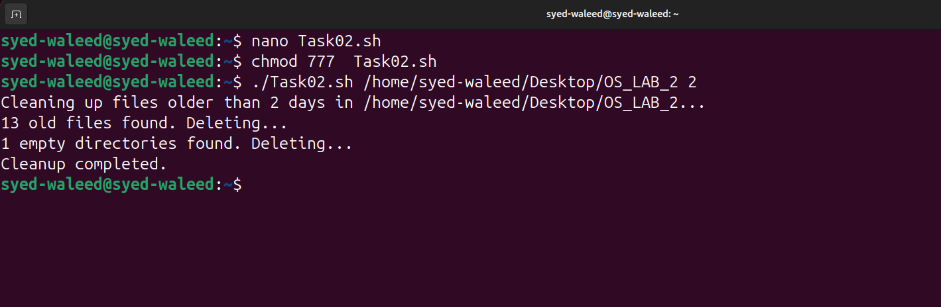

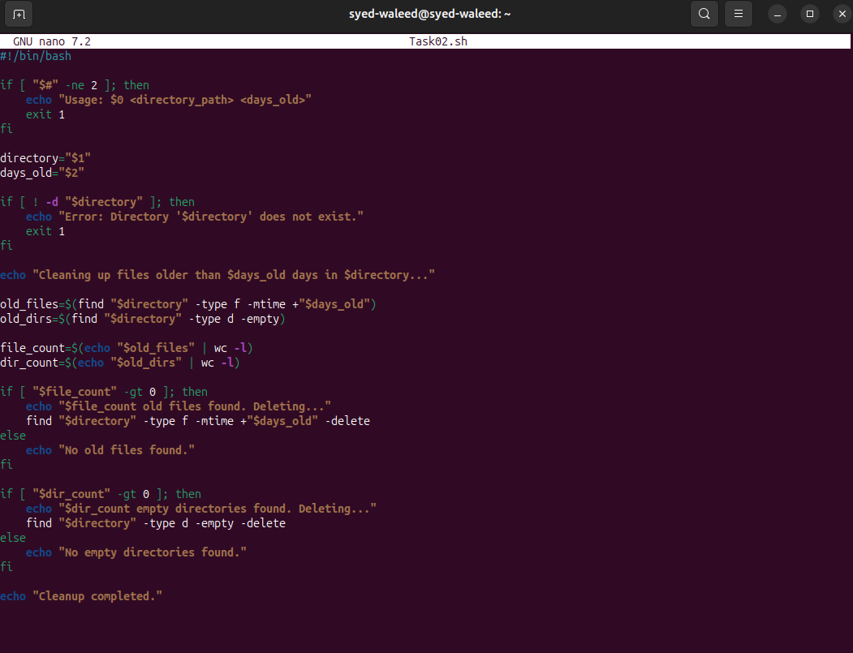

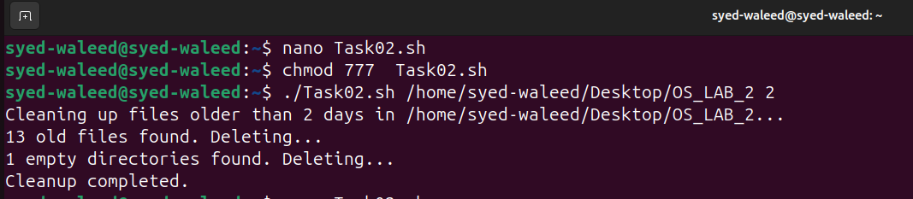

**Code:**

#!/bin/bash

if [ "$#" -ne 2 ]; then

echo "Usage: $0 <directory_path> <days_old>"

exit 1

fi

directory="$1"

days_old="$2"

if [ ! -d "$directory" ]; then

echo "Error: Directory '$directory' does not exist."

exit 1

fi

echo "Cleaning up files older than $days_old days in $directory..."

old_files=$(find "$directory" -type f -mtime +"$days_old")

old_dirs=$(find "$directory" -type d -empty)

file_count=$(echo "$old_files" | wc -l)

dir_count=$(echo "$old_dirs" | wc -l)

if [ "$file_count" -gt 0 ]; then

echo "$file_count old files found. Deleting..."

find "$directory" -type f -mtime +"$days_old" -delete

else

echo "No old files found."

fi

if [ "$dir_count" -gt 0 ]; then

echo "$dir_count empty directories found. Deleting..."

find "$directory" -type d -empty -delete

else

echo "No empty directories found."

fi

echo "Cleanup completed."

**Explanation:**

>if [ "$#" -ne 2 ]; To check only 2 Arguments as input

>if [ ! -d "$directory" ]; To check Directory exist or not

>old_files=$(find "$directory" -type f -mtime +"$days_old")

Used find to search in directory, -type f means we are searching for file type and –mtime +$days_old will search files given days old and this all will save in old_files

>file_count=$(echo "$old_files" | wc -l)

dir_count=$(echo "$old_dirs" | wc -l)

this will count how many directories and files are there

>-delete to delete

**Taskno_03:**

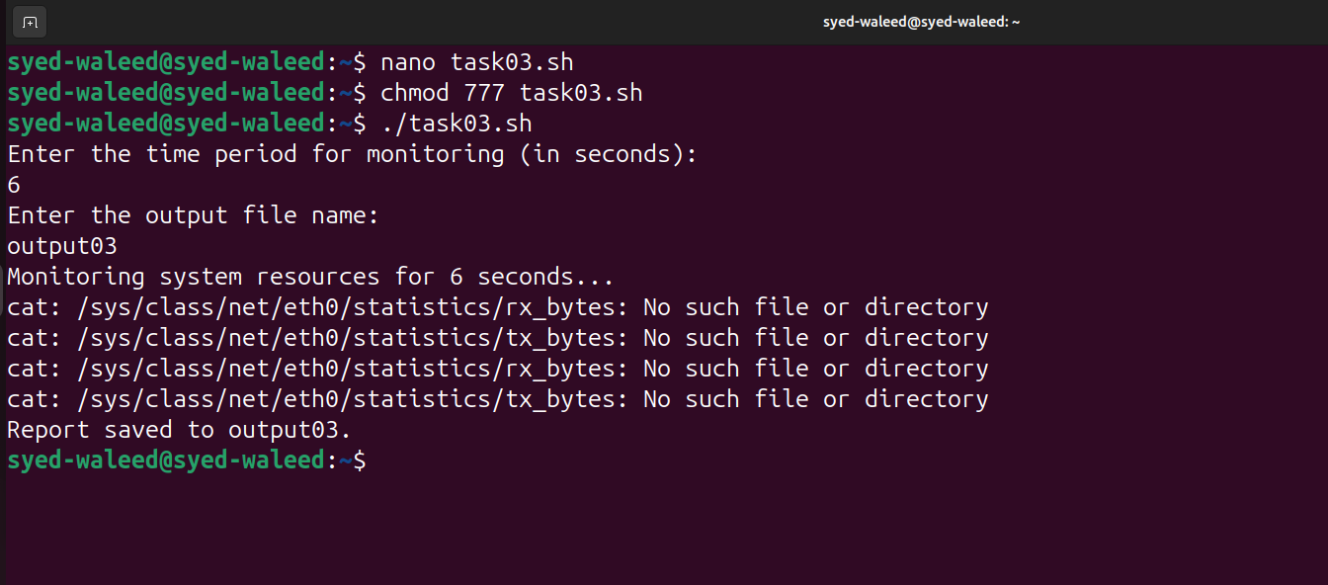

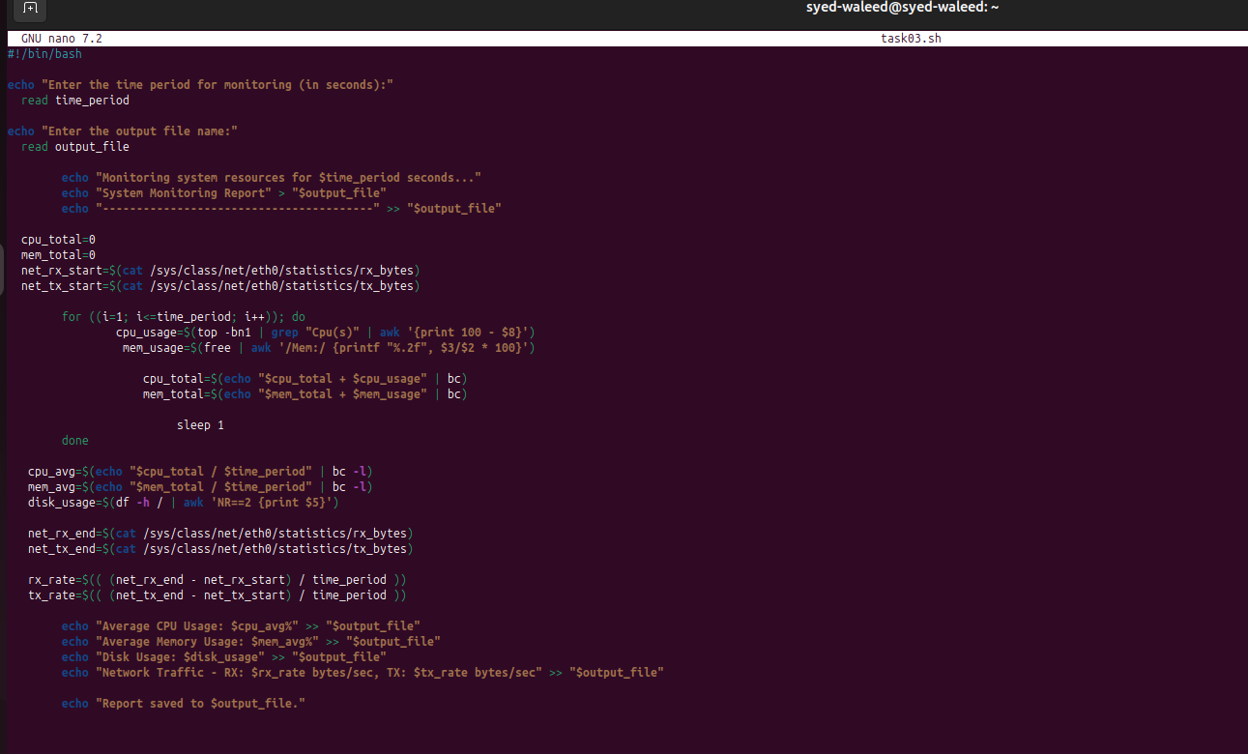

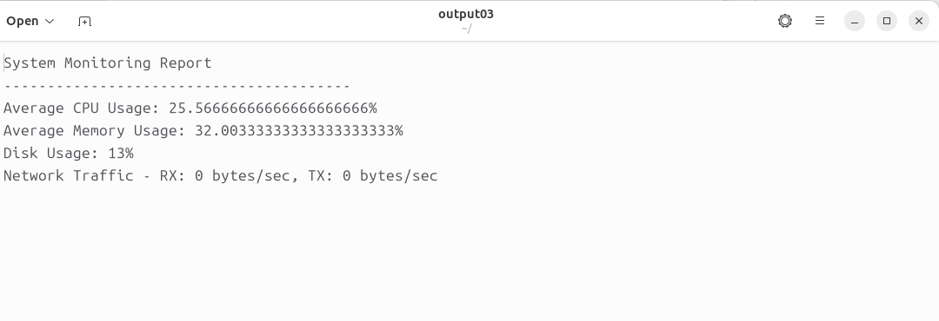

**Code:**

#!/bin/bash

echo "Enter the time period for monitoring (in seconds):"

read time_period

echo "Enter the output file name:"

read output_file

echo "Monitoring system resources for $time_period seconds..."

echo "System Monitoring Report" > "$output_file"

echo "----------------------------------------" >> "$output_file"

cpu_total=0

mem_total=0

net_rx_start=$(cat /sys/class/net/eth0/statistics/rx_bytes)

net_tx_start=$(cat /sys/class/net/eth0/statistics/tx_bytes)

for ((i=1; i<=time_period; i++)); do

cpu_usage=$(top -bn1 | grep "Cpu(s)" | awk '{print 100 - $8}')

mem_usage=$(free | awk '/Mem:/ {printf "%.2f", $3/$2 * 100}')

cpu_total=$(echo "$cpu_total + $cpu_usage" | bc)

mem_total=$(echo "$mem_total + $mem_usage" | bc)

sleep 1

done

cpu_avg=$(echo "$cpu_total / $time_period" | bc -l)

mem_avg=$(echo "$mem_total / $time_period" | bc -l)

disk_usage=$(df -h / | awk 'NR==2 {print $5}')

net_rx_end=$(cat /sys/class/net/eth0/statistics/rx_bytes)

net_tx_end=$(cat /sys/class/net/eth0/statistics/tx_bytes)

rx_rate=$(( (net_rx_end - net_rx_start) / time_period ))

tx_rate=$(( (net_tx_end - net_tx_start) / time_period ))

echo "Average CPU Usage: $cpu_avg%" >> "$output_file"

echo "Average Memory Usage: $mem_avg%" >> "$output_file"

echo "Disk Usage: $disk_usage" >> "$output_file"

echo "Network Traffic - RX: $rx_rate bytes/sec, TX: $tx_rate bytes/sec" >> "$output_file"

echo "Report saved to $output_file."

**Explanation:**

>’>’ to create output file in overwritemode

>net_rx_start=$(cat /sys/class/net/eth0/statistics/rx_bytes) net_tx_start=$(cat /sys/class/net/eth0/statistics/tx_bytes) to compute network speed

>cpu_usage=$(top -bn1 | grep "Cpu(s)" | awk '{print 100 - $8}') it Extracts the current CPU usage by subtracting the idle percentage ($8 field) from 100 using the top command.

> mem_usage=$(free | awk '/Mem:/ {printf "%.2f", $3/$2 * 100}') here free command to get memory usage and $3/$2 * 100 gives the percentage of usage

>cpu_total=$(echo "$cpu_total + $cpu_usage" | bc) mem_total=$(echo "$mem_total + $mem_usage" | bc) to sum

>bc to calculate the floating nmbrs

-----------------------------------------------------------------------------------------------------------------------------------------